LAB-3

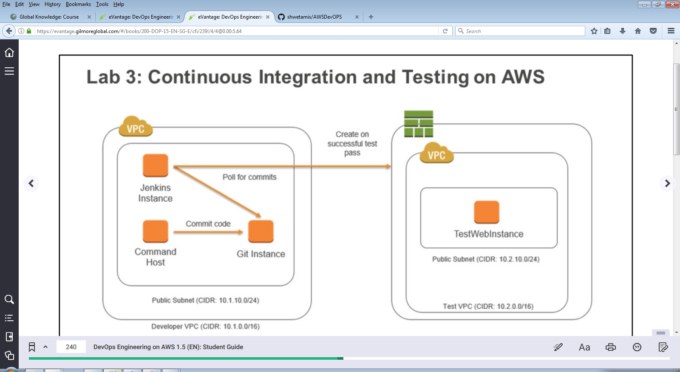

DevOps Engineering on AWS: Lab 3 - Continuous Integration - v1.5

==================================================================================================================

Using this command reference.

==================================================================================================================

1. Locate the section you need. Each section in this file matches a section in the lab instructions.

2. Replace items in angle brackets - < > - with appropriate values. For example, in this command you would replace the value - <JobFlowID> - (including the angle brackets) with the parameter indicated in the lab instructions:

elastic-mapreduce --list <JobFlowID>. You can also use find and replace to change bracketed parameters in bulk.

3. Do NOT enable the Word Wrap feature in Windows Notepad or the text editor you use to view this file.

++++1. Task: Initialize Continuous Integrations Framework

==================================================================================================================

1.2 Prepare the Git repository

==================================================================================================================

1.2.2 Create a new AWS CodeCommit Repository

aws codecommit create-repository --repository-name <repo name> --region us-east-1

1.2.3 View the contents of the setup script and run the setup script to configure permissions for CodeCommit

cat ./setup-codecommit.sh

./setup-codecommit.sh

1.2.4 Reload the bash_profile to enable profile:developer1

source ~/.bash_profile

1.2.5 Navigate to the local CI directory

cd /opt/git/ci-project

1.2.6 Initialize local Git repository

git init

1.2.7 Retrieve sample content

wget -O cfn/lab-3-app-test-env.template https://d2lrzjb0vjvpn5.cloudfront.net/devops/v1.5/lab-3-ci/static/lab-3-app-test-env.template

wget -O ~/sample-app.tgz https://d2lrzjb0vjvpn5.cloudfront.net/devops/v1.5/lab-3-ci/static/sample-app.tgz

1.2.8 Create simple text file

printf "################################\n\nMain branch initialized `date`.\n\n" >> readme.txt

1.2.9 Add files to Git repository

git add .

1.2.10 Commit files to Git repository

git commit -m "Initializing Git master branch"

1.2.11 Configure remote for CodeCommit repository

git remote add origin <cloneUrlSsh>

1.2.12 Push your commits to the origin

git push origin master

==================================================================================================================

1.3 Fork Branches

==================================================================================================================

1.3.1 Create symbolic link for unit testing

sudo ln -s /opt/git/ci-project/php /var/www/html/php

1.3.2 Create a new branch in your local Git repository

git checkout -b newWidget

1.3.3 Verify working branch

git branch

1.3.4 Update readme.txt

printf "################################\n\nInitialized newWidget branch `date`.\n\n" >> readme.txt

1.3.5 Add the readme file to a checkin

git add readme.txt

1.3.6 Commit the change

git commit -m "Recorded creation of new branch in readme.txt"

1.3.7 Push the commit to AWS CodeCommit

git push origin newWidget

1.3.8 Display current content of the readme.txt file

git show :readme.txt

1.3.9 Switch branches

git checkout master

1.3.10 View readme.txt in the master branch

git show :readme.txt

1.3.11 Switch back to the newWidget branch

git checkout newWidget

1.3.12 Extract the contents of the sample app

tar -xvf ~/sample-app.tgz -C /opt/git/ci-project/.

1.3.13 Browse to the custom app

http://<CommandHostPublicIp>/php/

==================================================================================================================

1.4 Create Automated Validation Jobs

==================================================================================================================

1.4.7 Add the branch to build

*/newWidget

1.4.9 Copy into the Schedule field

* * * * *

1.4.12 Add validation script

#!/bin/bash

/var/lib/jenkins/script/simple-test.sh

==================================================================================================================

1.5 Validate and Repair

==================================================================================================================

1.5.5 Ensure correct working directory

cd /opt/git/ci-project

1.5.6 Open up file for editing

vi cfn/lab-3-app-test-env.template

1.5.9 Add the change to the newWidget branch

git add cfn/lab-3-app-test-env.template

1.5.10 Commit changes

git commit -m "Corrected an issue with the test environment template"

1.5.11 Push changes to Git

git push origin newWidget

==================================================================================================================

1.6 Merge, Validate, and Deploy

==================================================================================================================

1.6.8 Jenkins shell command

#!/bin/bash

/var/lib/jenkins/script/test-build-deploy.sh

1.6.10 Confirm the current branch

git branch

If the result is master, switch back to newWidget:

git checkout newWidget

1.6.11 Add the changes

git add .

1.6.12 Commit the changes

git commit -m "Completed v1.0 of sample app"

1.6.13 Push the changes to the Git server

git push origin newWidget

1.6.16 Check out the master branch

git checkout master

1.6.17 Merge the newWidget branch into the master branch

git merge newWidget

1.6.18 Push the merged changes into the master branch

git push origin master

© 2017 Amazon Web Services, Inc. or its affiliates. All rights reserved.

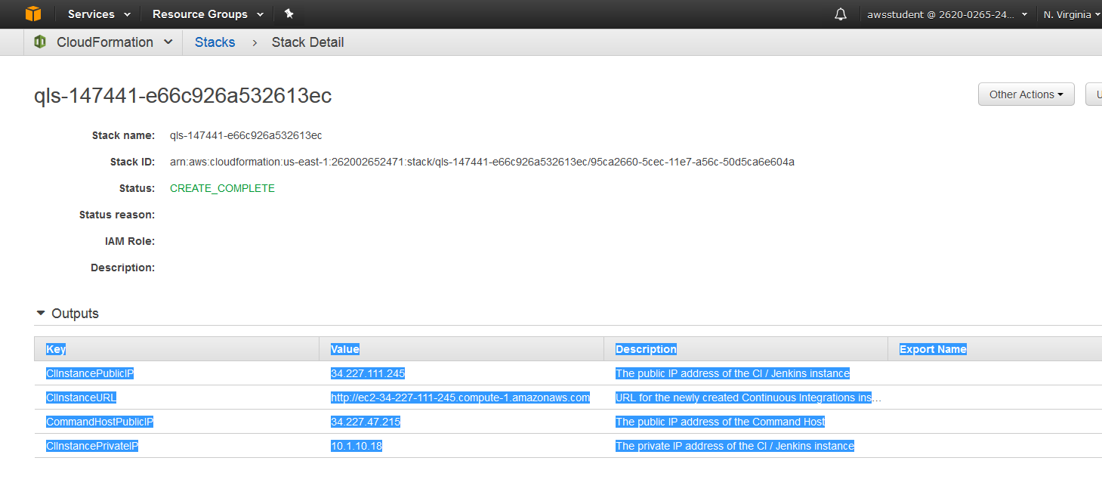 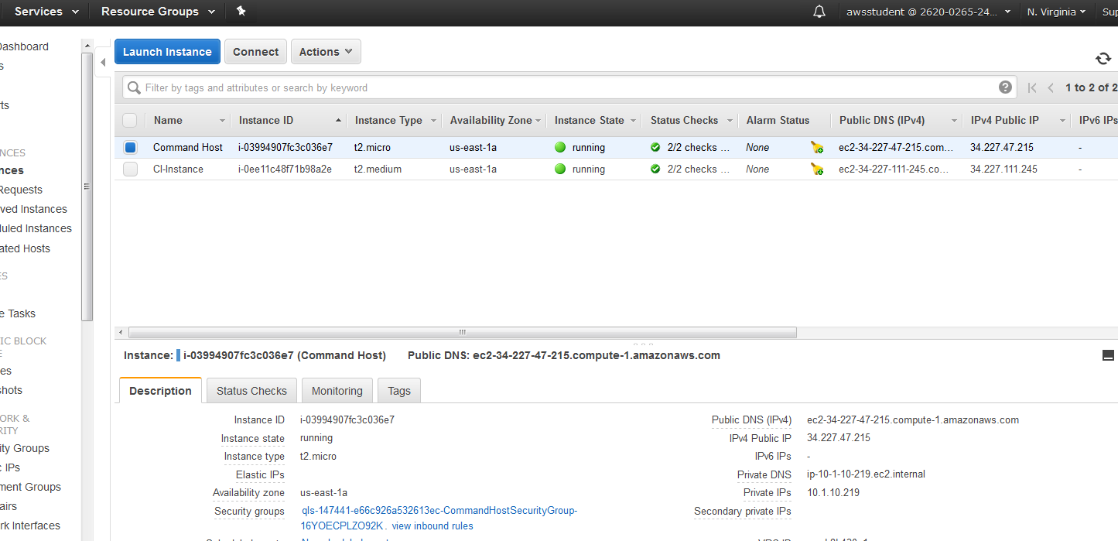

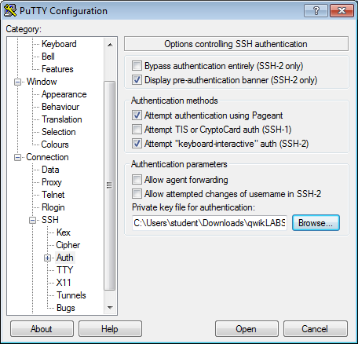 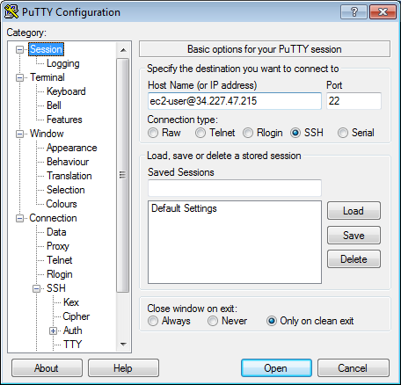

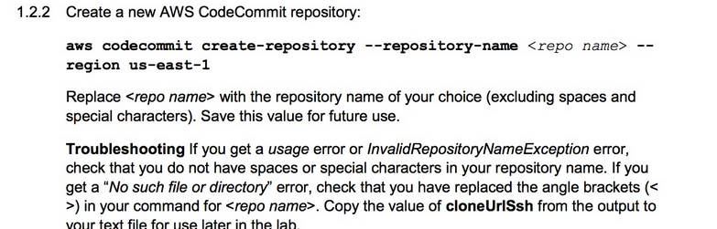

aws codecommit create-repository --repository-name shwetamisra --region us-east-1

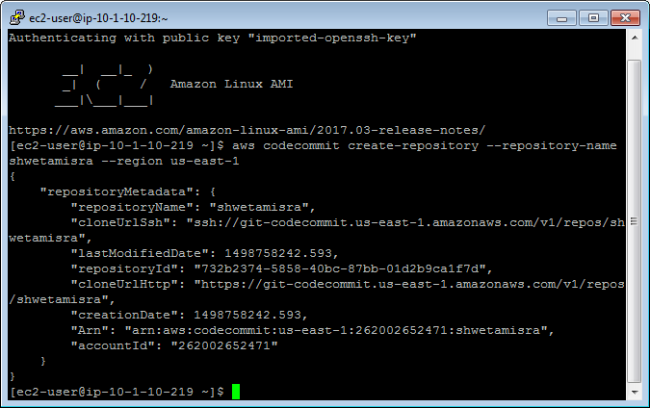

1.2.3 View the contents of the setup script and run the setup script to configure permissions for CodeCommit

cat ./setup-codecommit.sh

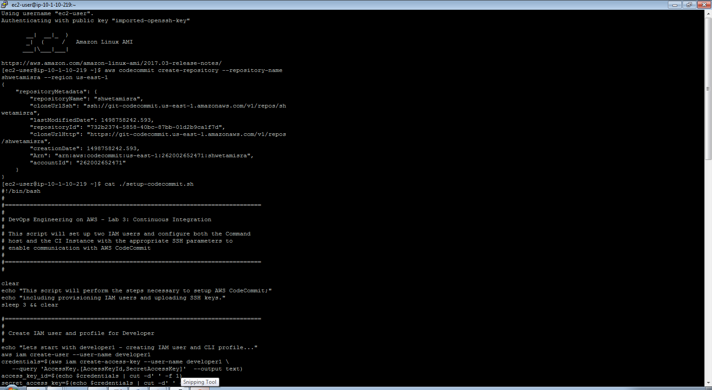

./setup-codecommit.sh

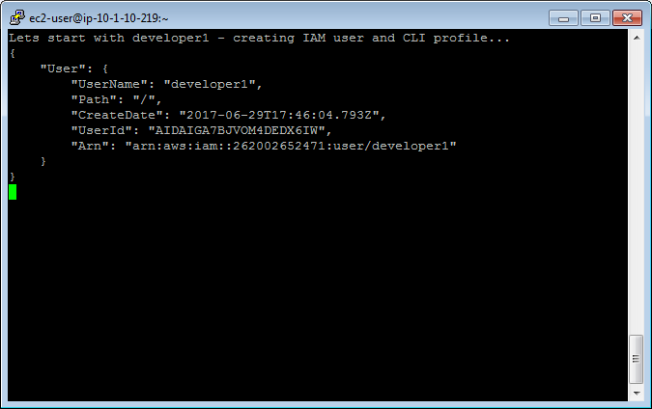

1.2.4 Reload the bash_profile to enable profile:developer1

source ~/.bash_profile

1.2.5 Navigate to the local CI directory

cd /opt/git/ci-project

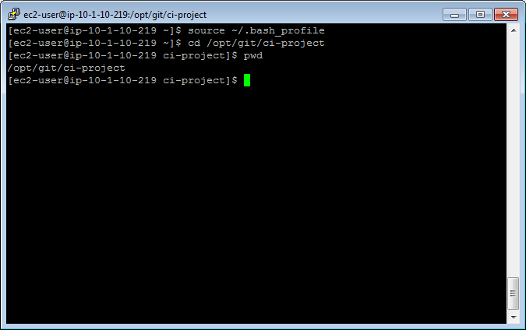

1.2.6 Initialize local Git repository

git init

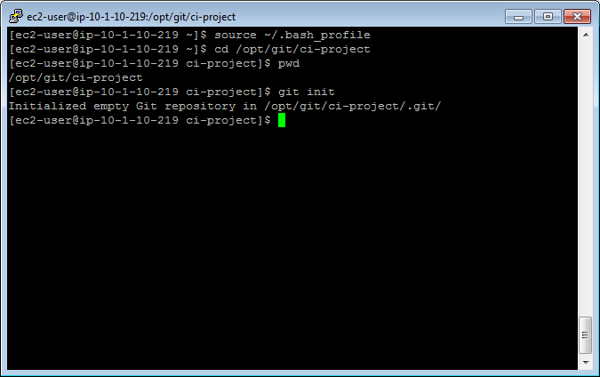

1.2.7 Retrieve sample content

wget -O cfn/lab-3-app-test-env.template https://d2lrzjb0vjvpn5.cloudfront.net/devops/v1.5/lab-3-ci/static/lab-3-app-test-env.template

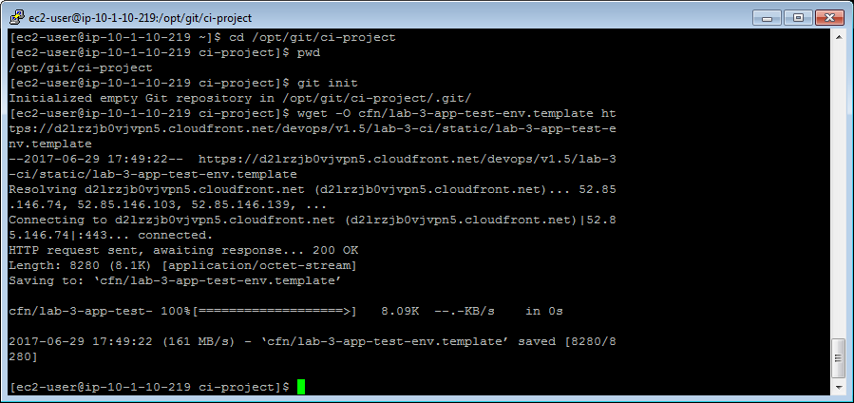

wget -O ~/sample-app.tgz https://d2lrzjb0vjvpn5.cloudfront.net/devops/v1.5/lab-3-ci/static/sample-app.tgz

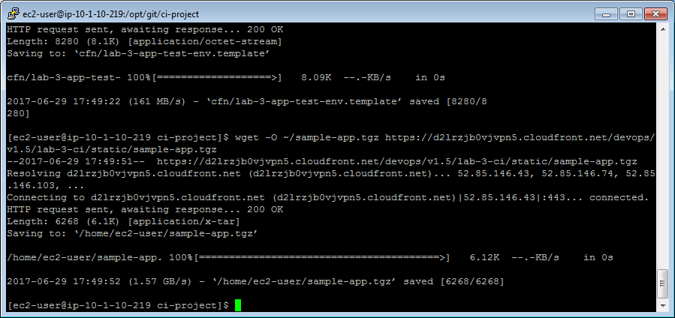

1.2.8 Create simple text file

printf "################################\n\nMain branch initialized `date`.\n\n" >> readme.txt

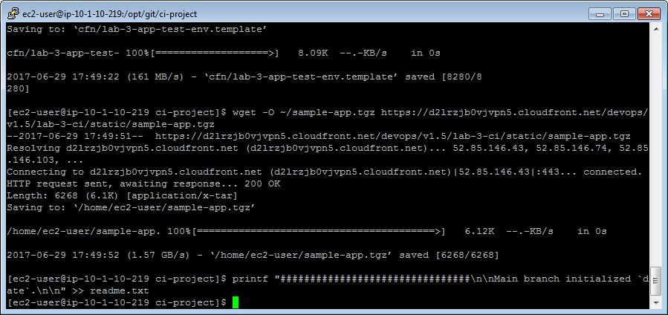

1.2.9 Add files to Git repository

git add .

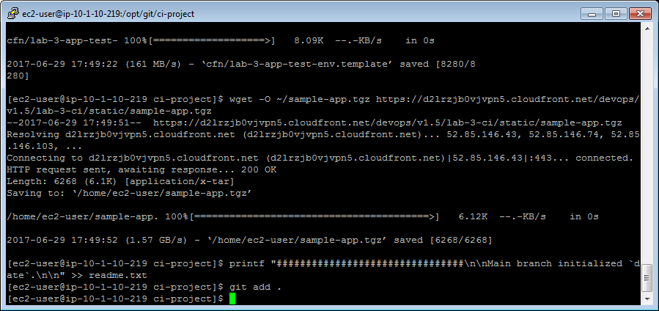

1.2.10 Commit files to Git repository

git commit -m "Initializing Git master branch"

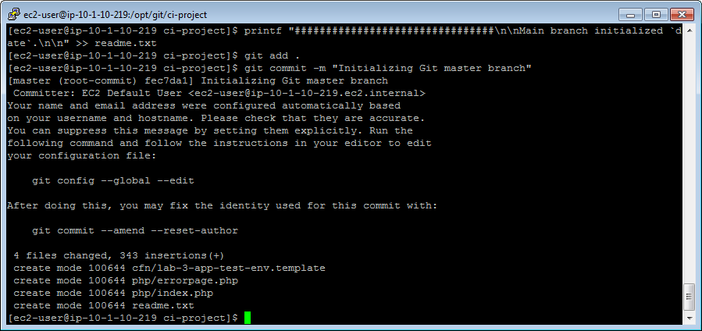

1.2.11 Configure remote for CodeCommit repository

git remote add origin <cloneUrlSsh>

git remote add origin ssh://git-codecommit.us-east-1.amazonaws.com/v1/repos/shwetamisra

"cloneUrlSsh": "ssh://git-codecommit.us-east-1.amazonaws.com/v1/repos/sh wetamisra",

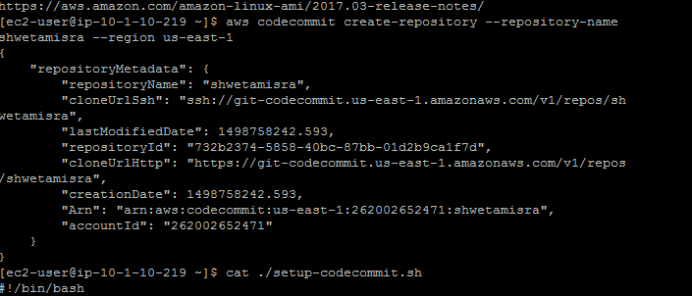

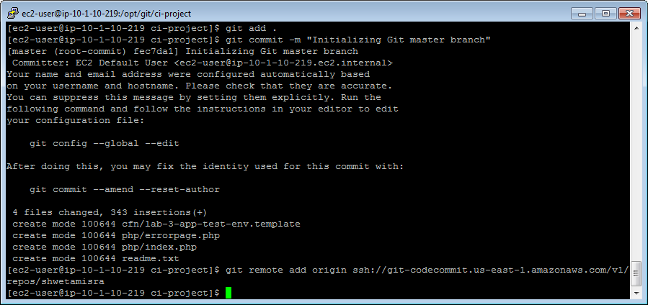

1.2.12 Push your commits to the origin

git push origin master

==================================================================================================================

1.3 Fork Branches

==================================================================================================================

1.3.1 Create symbolic link for unit testing

sudo ln -s /opt/git/ci-project/php /var/www/html/php

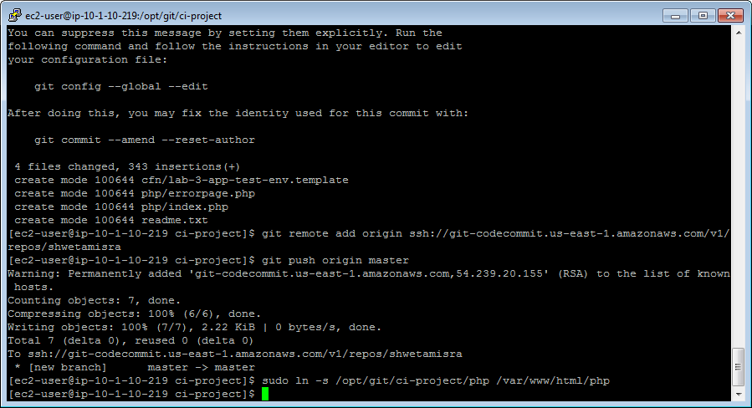

1.3.2 Create a new branch in your local Git repository

git checkout -b newWidget

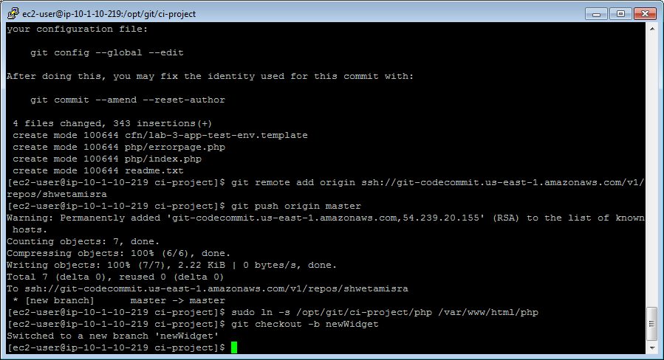

1.3.3 Verify working branch

git branch

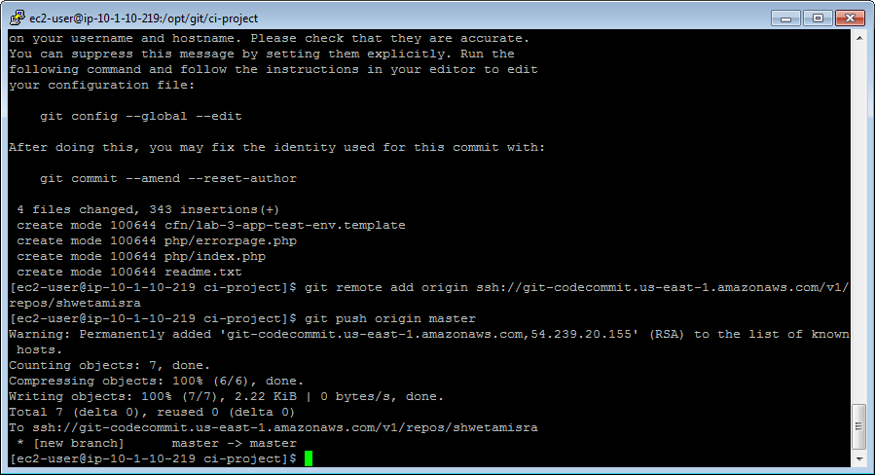

1.3.4 Update readme.txt

printf "################################\n\nInitialized newWidget branch `date`.\n\n" >> readme.txt

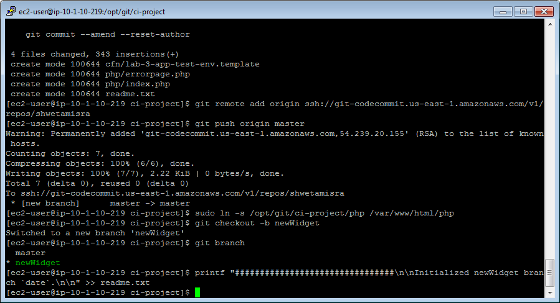

1.3.5 Add the readme file to a checkin

git add readme.txt

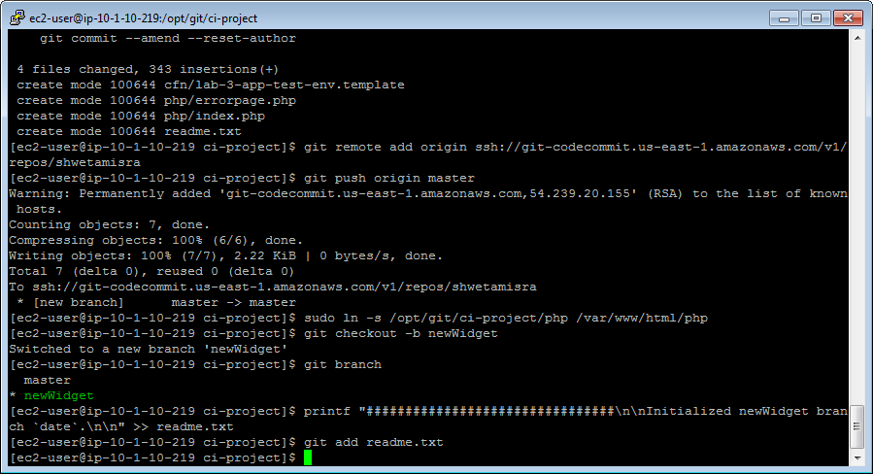

1.3.6 Commit the change

git commit -m "Recorded creation of new branch in readme.txt"

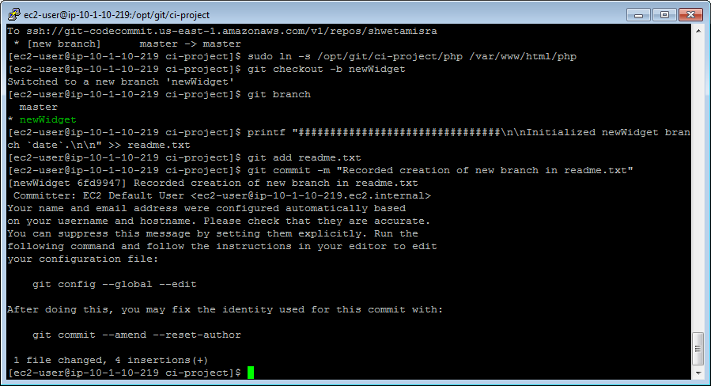

1.3.7 Push the commit to AWS CodeCommit

git push origin newWidget

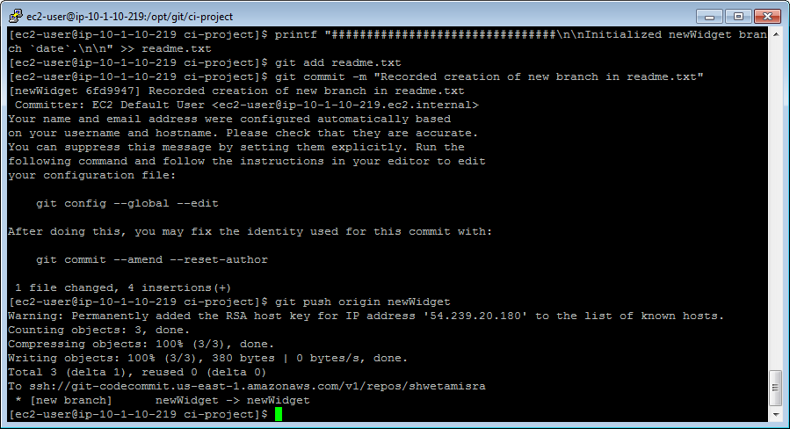

1.3.8 Display current content of the readme.txt file

git show :readme.txt

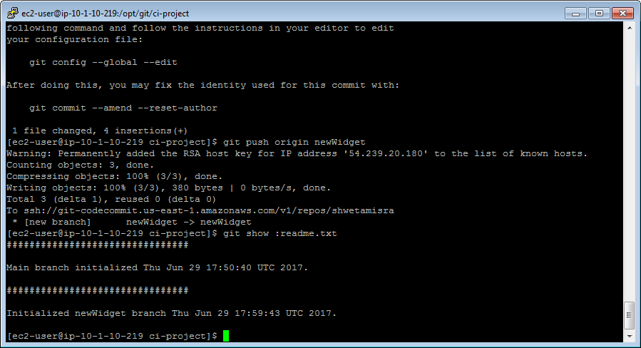

1.3.9 Switch branches

git checkout master

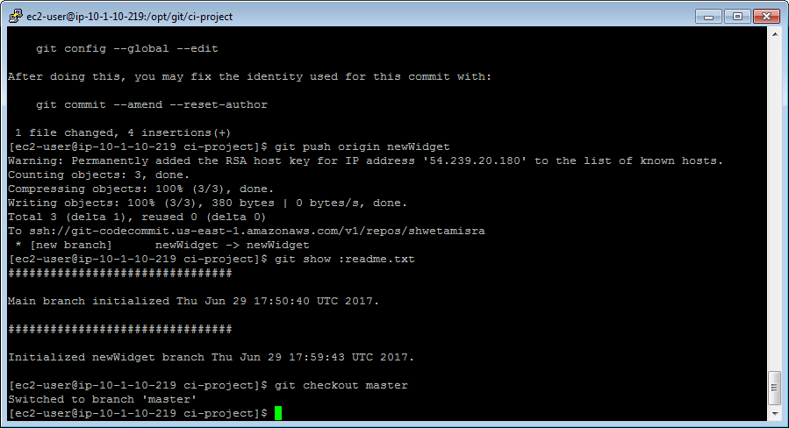

1.3.10 View readme.txt in the master branch

git show :readme.txt

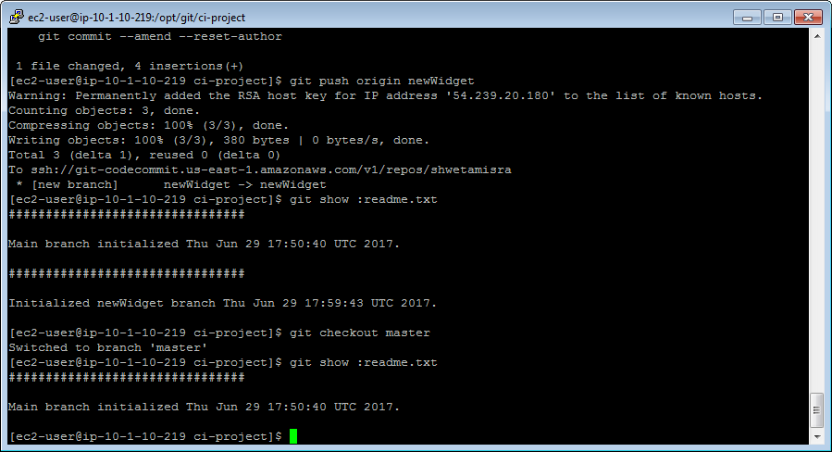

1.3.11 Switch back to the newWidget branch

git checkout newWidget

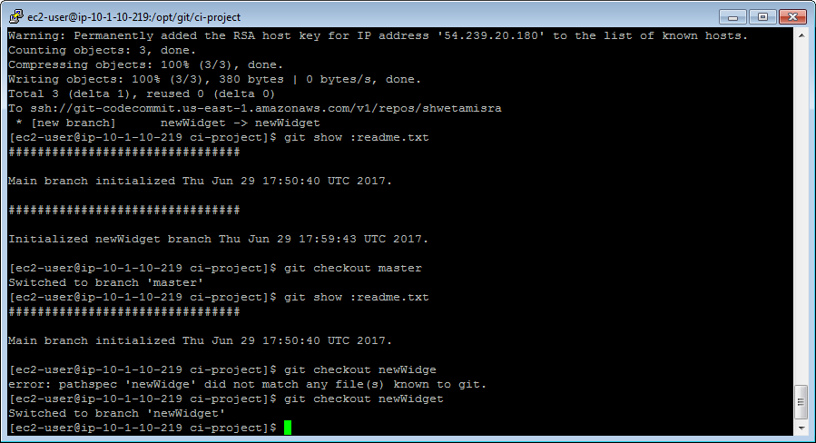

1.3.12 Extract the contents of the sample app

tar -xvf ~/sample-app.tgz -C /opt/git/ci-project/.

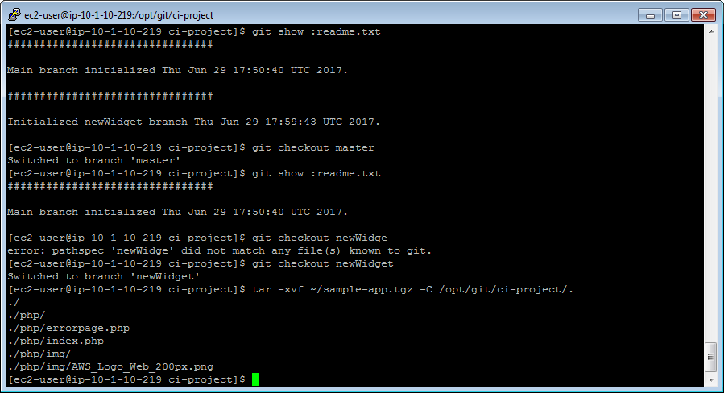

1.3.13 Browse to the custom app

http://<CommandHostPublicIp>/php/

(<CommandHostPublicIp>: copied from cloud formation output)

http://34.227.47.215/php/

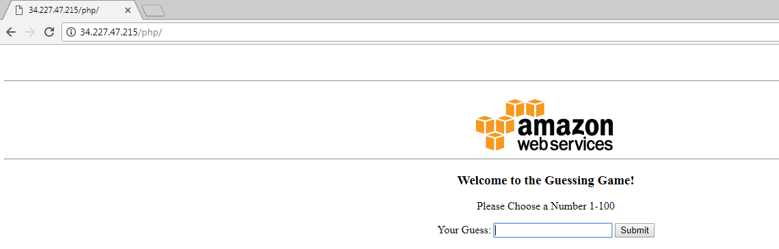

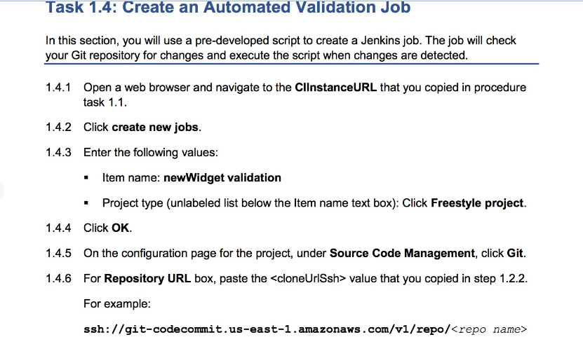

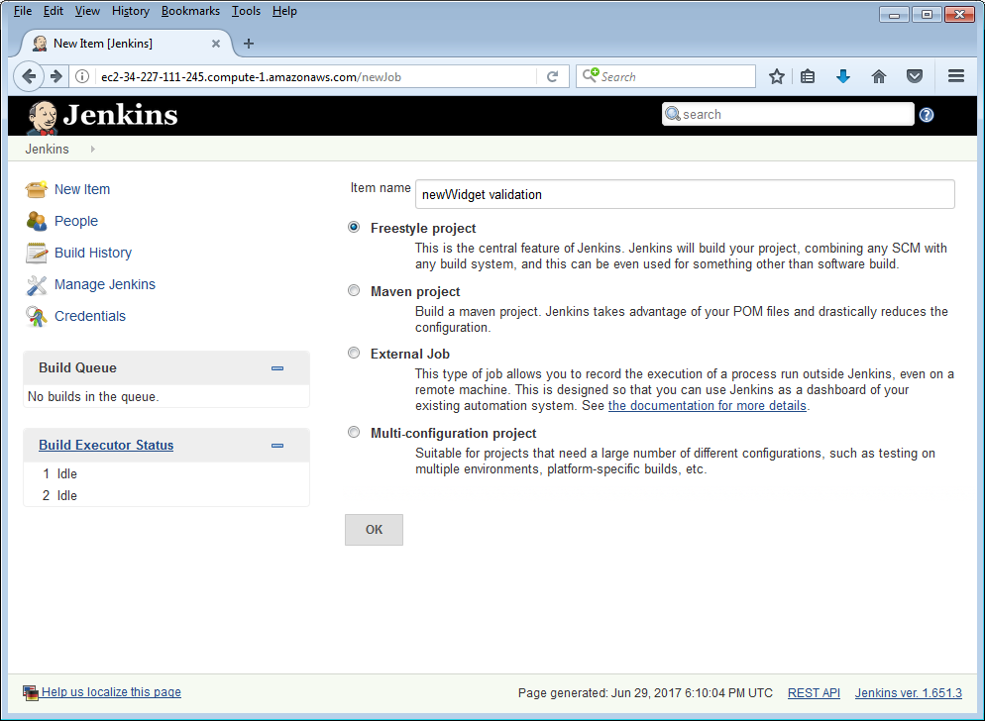

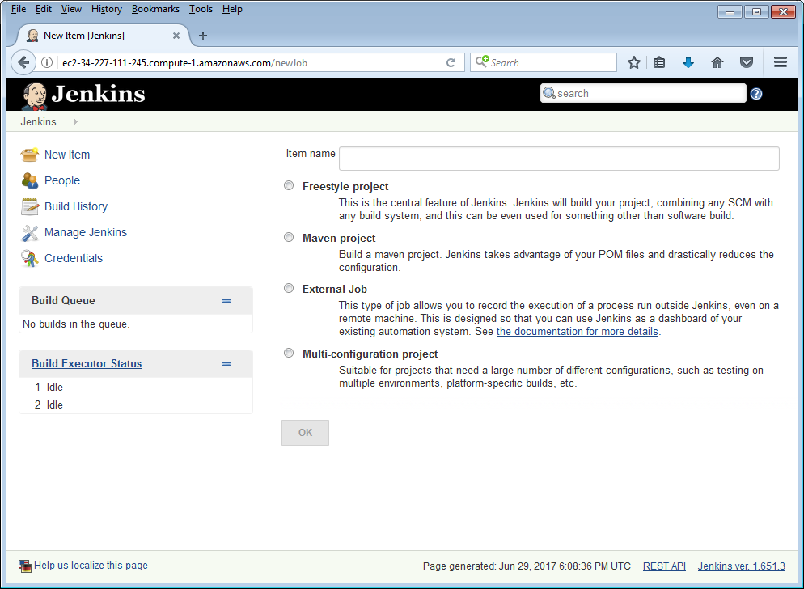

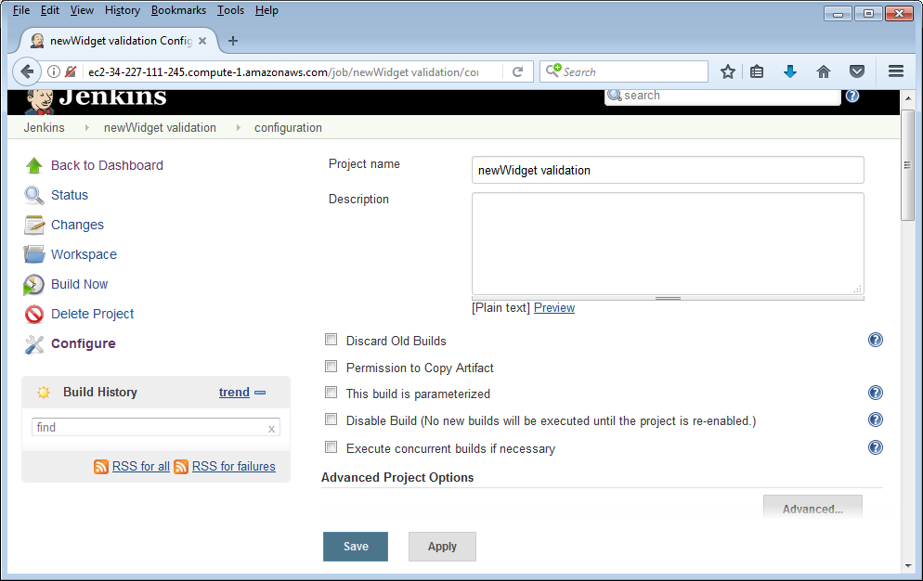

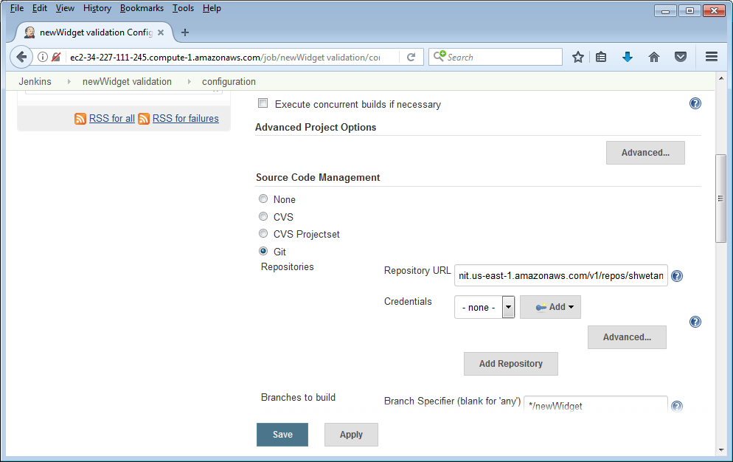

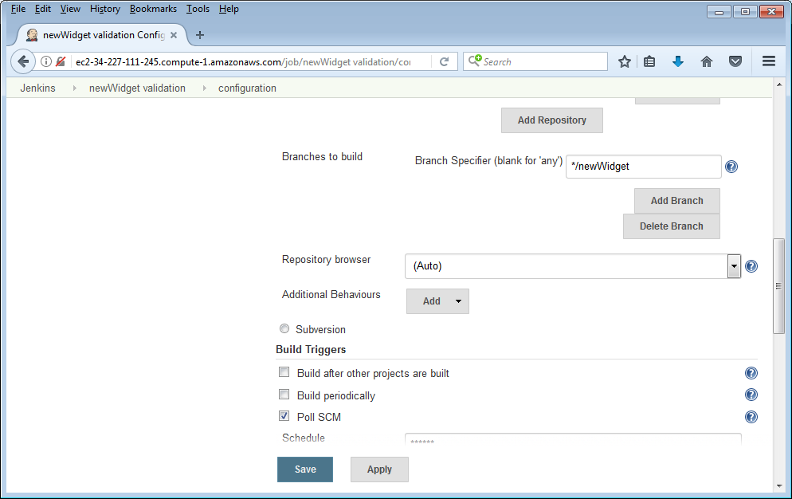

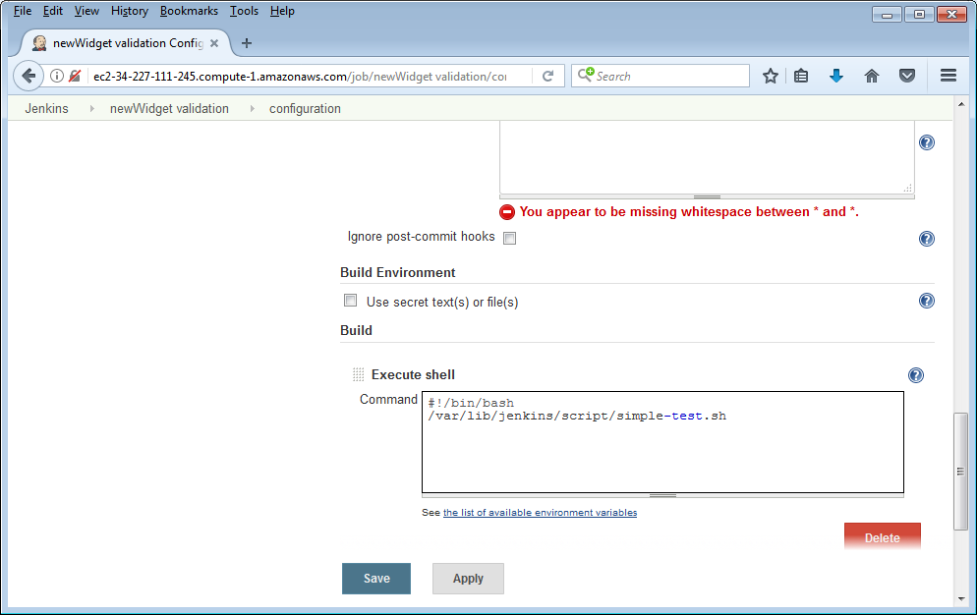

==================================================================================================================

1.4 Create Automated Validation Jobs

==================================================================================================================

1.4.7 Add the branch to build

*/newWidget

1.4.9 Copy into the Schedule field

* * * * *

1.4.12 Add validation script

#!/bin/bash

/var/lib/jenkins/script/simple-test.sh

==============================================

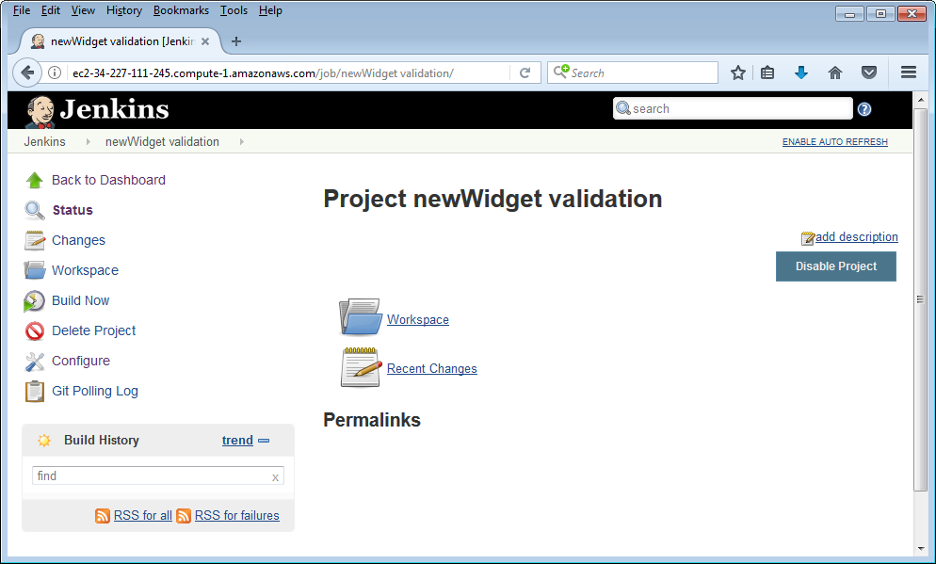

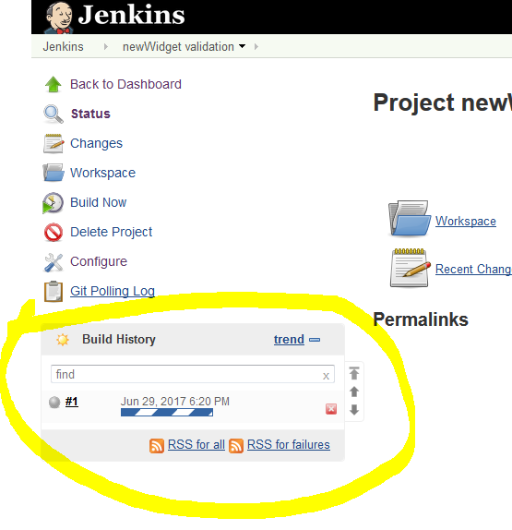 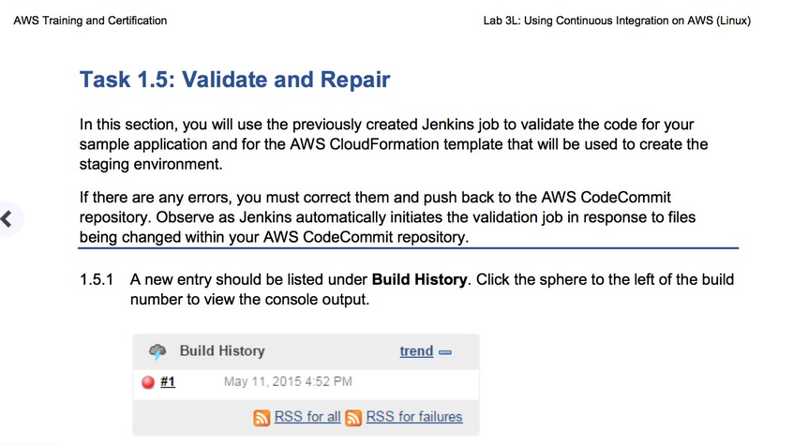

Errors

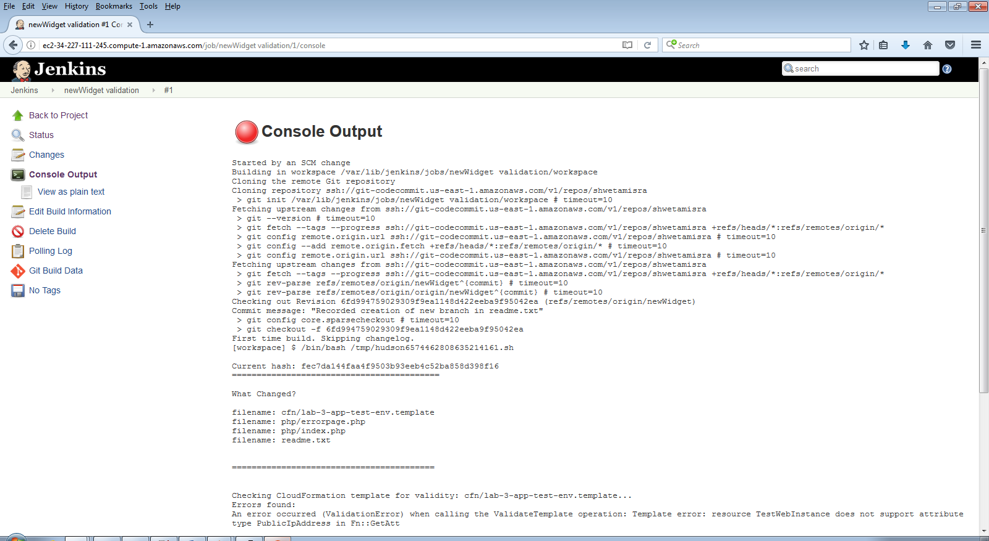 Started by an SCM change

Building in workspace /var/lib/jenkins/jobs/newWidget validation/workspace

Cloning the remote Git repository

Cloning repository ssh://git-codecommit.us-east-1.amazonaws.com/v1/repos/shwetamisra

> git init /var/lib/jenkins/jobs/newWidget validation/workspace # timeout=10

Fetching upstream changes from ssh://git-codecommit.us-east-1.amazonaws.com/v1/repos/shwetamisra

> git --version # timeout=10

> git fetch --tags --progress ssh://git-codecommit.us-east-1.amazonaws.com/v1/repos/shwetamisra +refs/heads/*:refs/remotes/origin/*

> git config remote.origin.url ssh://git-codecommit.us-east-1.amazonaws.com/v1/repos/shwetamisra # timeout=10

> git config --add remote.origin.fetch +refs/heads/*:refs/remotes/origin/* # timeout=10

> git config remote.origin.url ssh://git-codecommit.us-east-1.amazonaws.com/v1/repos/shwetamisra # timeout=10

Fetching upstream changes from ssh://git-codecommit.us-east-1.amazonaws.com/v1/repos/shwetamisra

> git fetch --tags --progress ssh://git-codecommit.us-east-1.amazonaws.com/v1/repos/shwetamisra +refs/heads/*:refs/remotes/origin/*

> git rev-parse refs/remotes/origin/newWidget^{commit} # timeout=10

> git rev-parse refs/remotes/origin/origin/newWidget^{commit} # timeout=10

Checking out Revision 6fd994759029309f9ea1148d422eeba9f95042ea (refs/remotes/origin/newWidget)

Commit message: "Recorded creation of new branch in readme.txt"

> git config core.sparsecheckout # timeout=10

> git checkout -f 6fd994759029309f9ea1148d422eeba9f95042ea

First time build. Skipping changelog.

[workspace] $ /bin/bash /tmp/hudson6574462808635214161.sh

Current hash: fec7da144faa4f9503b93eeb4c52ba858d398f16

==========================================

What Changed?

filename: cfn/lab-3-app-test-env.template

filename: php/errorpage.php

filename: php/index.php

filename: readme.txt

=========================================

Checking CloudFormation template for validity: cfn/lab-3-app-test-env.template...

Errors found:

An error occurred (ValidationError) when calling the ValidateTemplate operation: Template error: resource TestWebInstance does not support attribute type PublicIpAddress in Fn::GetAtt

Checking PHP File: php/errorpage.php

No errors found!

Checking PHP File: php/index.php

No errors found!

=========================================

Encountered errors!! Please correct errors in the following file(s):

cfn/lab-3-app-test-env.template

Build step 'Execute shell' marked build as failure

Finished: FAILURE

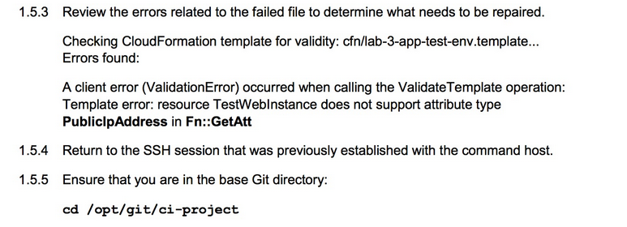 ==================================================================================================================

1.5 Validate and Repair

==================================================================================================================

1.5.5 Ensure correct working directory

cd /opt/git/ci-project

1.5.6 Open up file for editing

vi cfn/lab-3-app-test-env.template

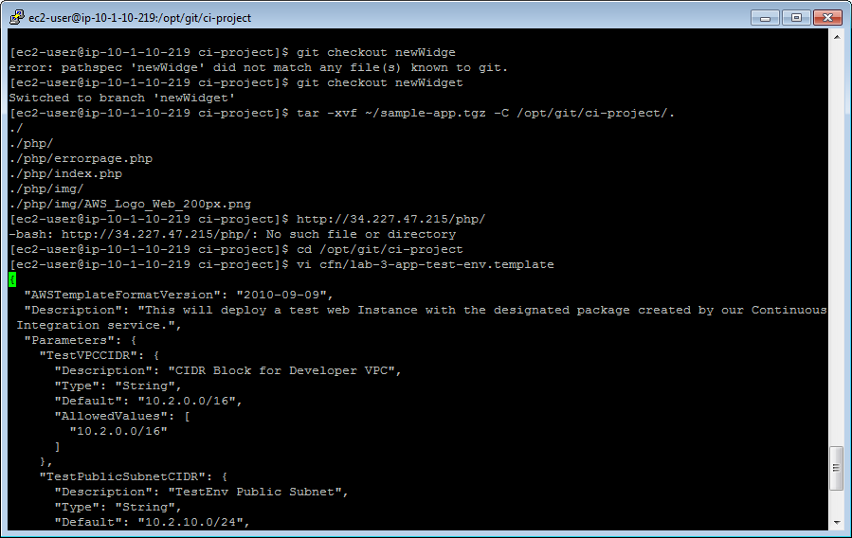

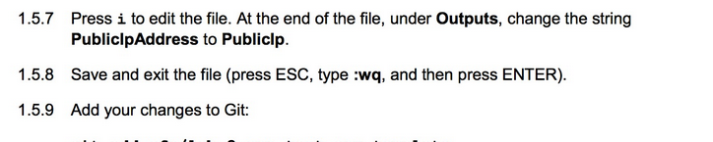

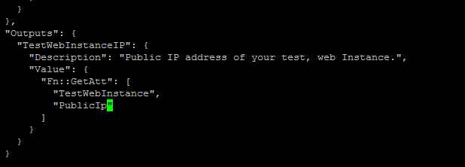

1.5.9 Add the change to the newWidget branch

git add cfn/lab-3-app-test-env.template

1.5.10 Commit changes

git commit -m "Corrected an issue with the test environment template"

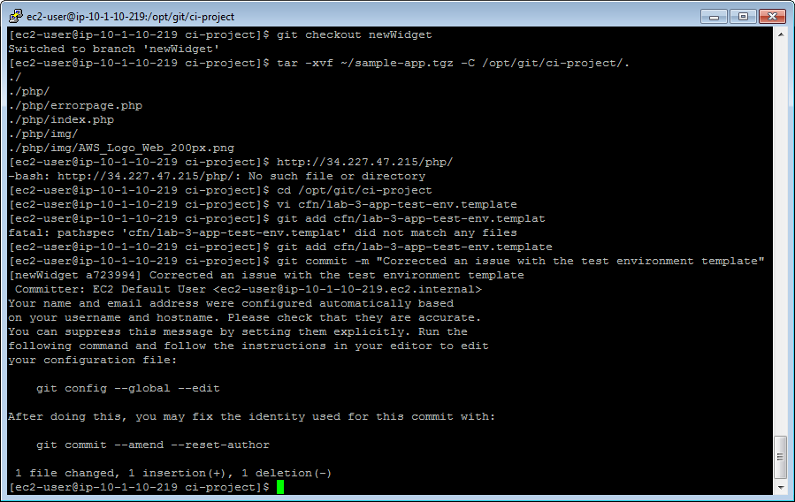

1.5.11 Push changes to Git

git push origin newWidget

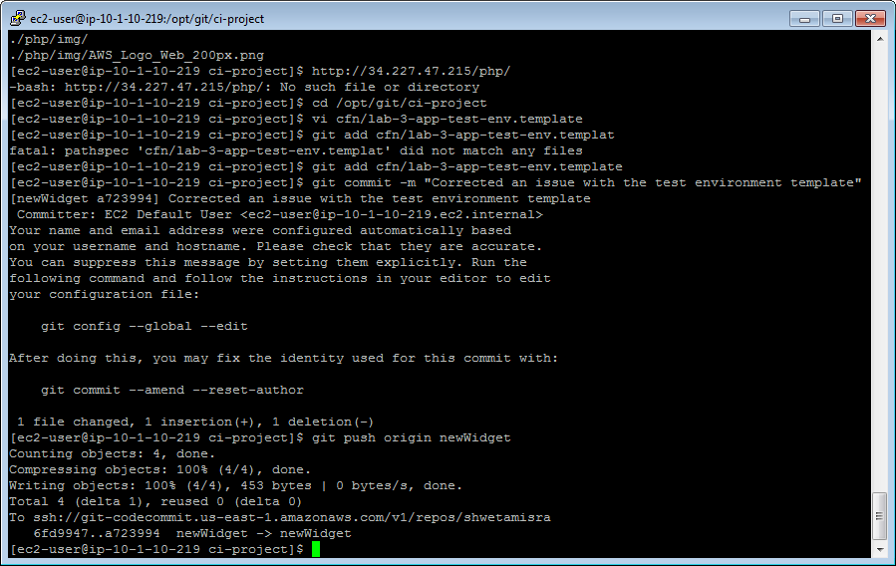

==================================================================================================================

1.6 Merge, Validate, and Deploy

==================================================================================================================

1.6.8 Jenkins shell command

#!/bin/bash

/var/lib/jenkins/script/test-build-deploy.sh

1.6.10 Confirm the current branch

git branch

If the result is master, switch back to newWidget:

git checkout newWidget

1.6.11 Add the changes

git add .

1.6.12 Commit the changes

git commit -m "Completed v1.0 of sample app"

1.6.13 Push the changes to the Git server

git push origin newWidget

1.6.16 Check out the master branch

git checkout master

1.6.17 Merge the newWidget branch into the master branch

git merge newWidget

1.6.18 Push the merged changes into the master branch

git push origin master

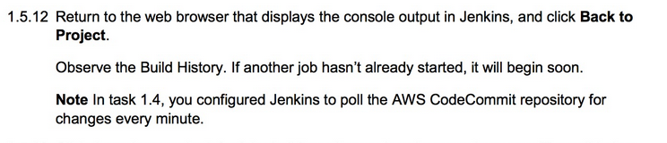

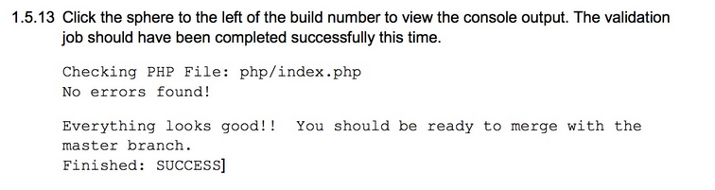

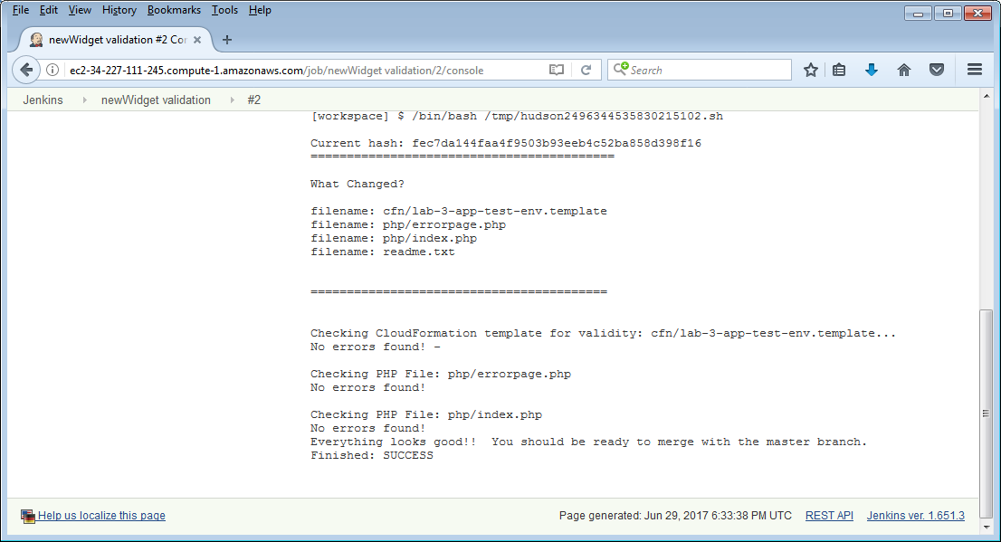

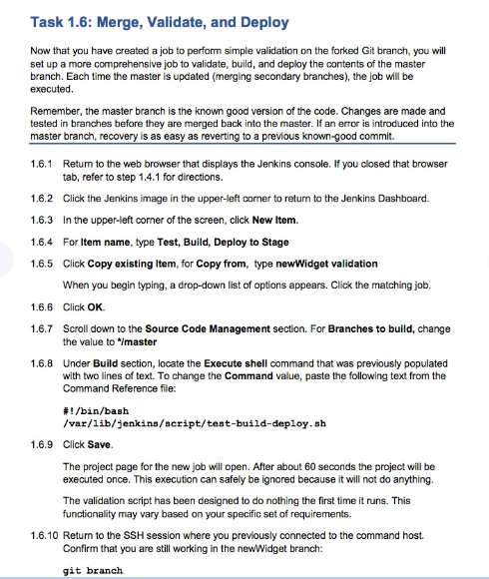

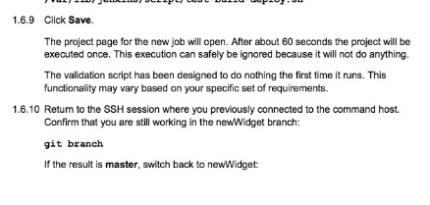 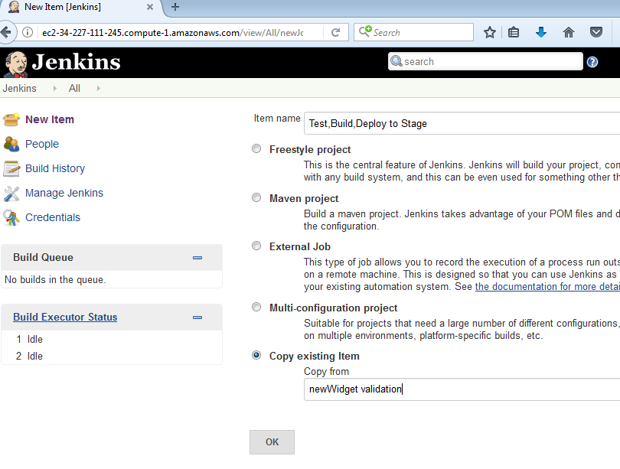 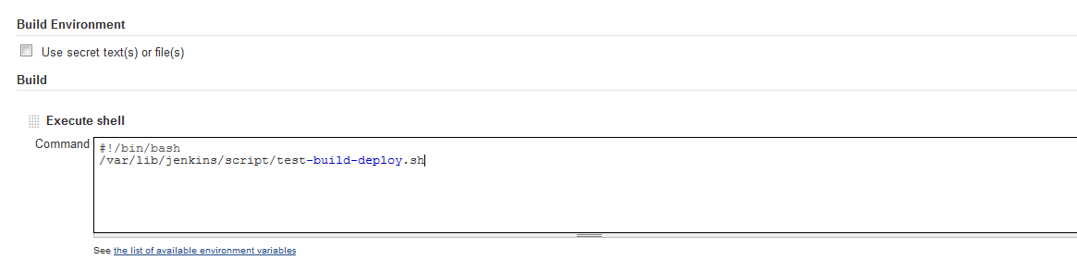 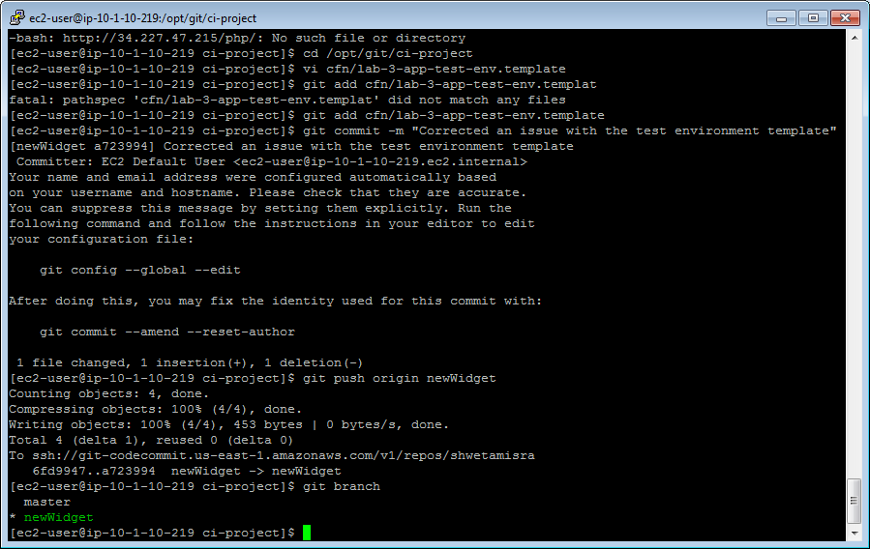

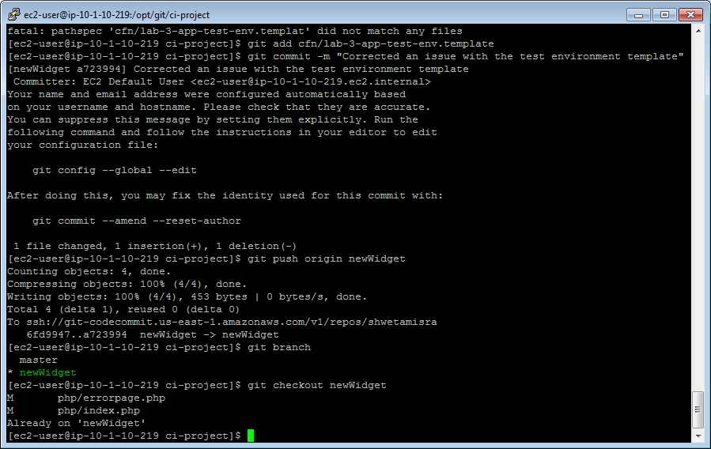

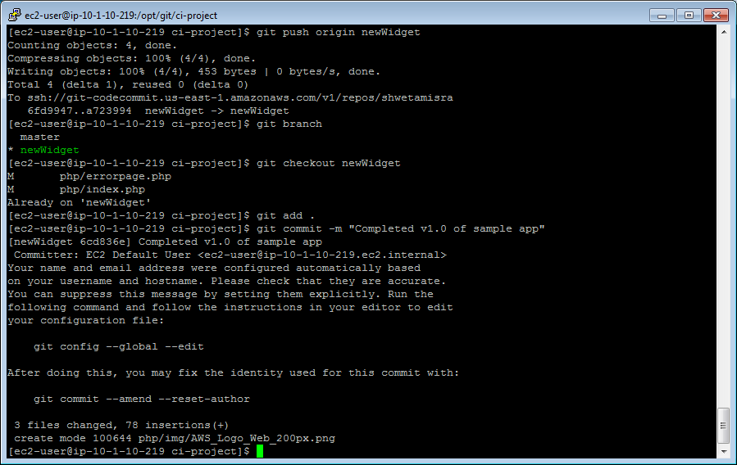 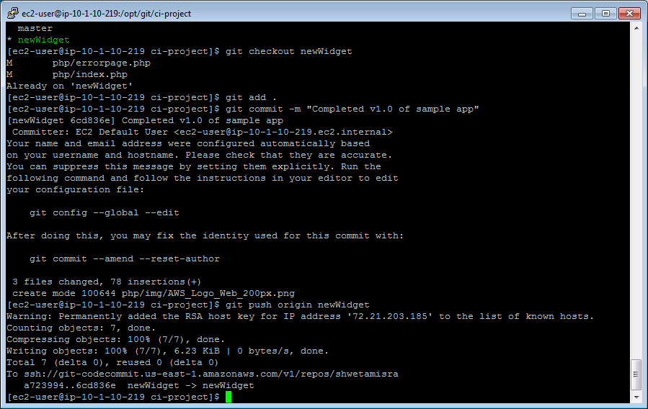 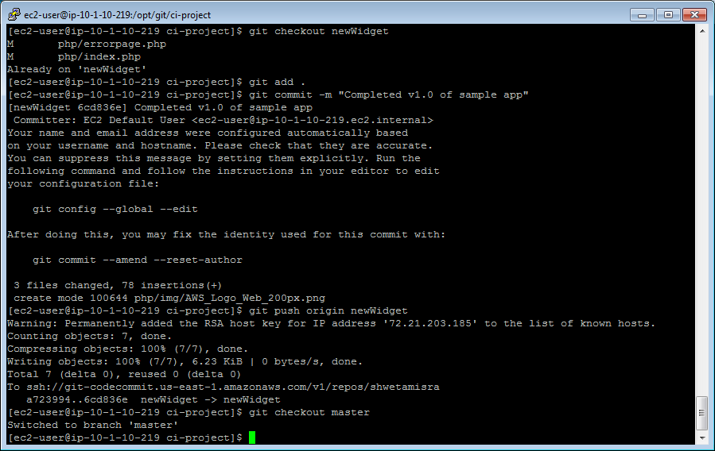

1.6.17 Merge the newWidget branch into the master branch

git merge newWidget

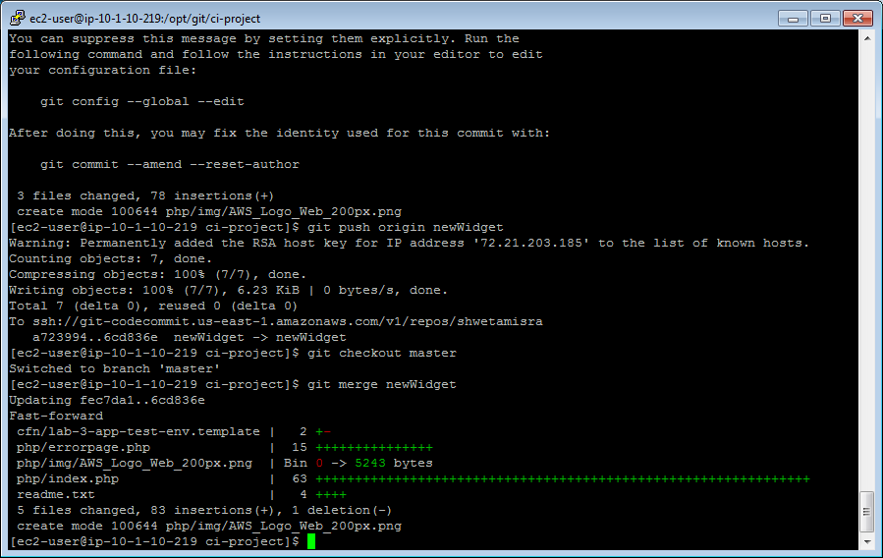

1.6.18 Push the merged changes into the master branch

git push origin master

